Retül Bike Measurements Explained

In addition to Retül being an amazing tool for measuring the body, it’s also a brilliant tool for measuring bikes. The Team Sky mechanics use it to set up each of the rider’s bikes exactly correct to the mm. Having an electronic copy of your bike set up saved somewhere online is very important so that you can refer to it anywhere in the world. To give you an example, when I did the Junior World Champs in Athens, our bikes conveniently got on a flight to Moscow. During the 2 days it took to get the bikes back to us, we had to borrow bikes from the Greek national squad. Now, because I had saved my position details online, I was able to adjust my bike so that it fitted fine. My colleagues however spent a whole ride with tools in their pockets, stopping every 5 minutes to fiddle with their position. One guy actually picked up a knee niggle from riding in the wrong position.

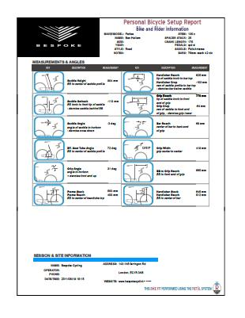

So at the end of the fitting process, we scan your bike and you become the proud owner of the above PDF document. But what if you want to replicate this position on a second bike? Well, I’ll tell you a few handy tips that can quickly get the position dialled. Firstly, using the same saddle across all of your bikes is a very good idea. Each saddle has a different length nose and is designed to support you in slightly different place. Having a consistent contact point will lead to fewer problems setting up the same position between bikes. Secondly, you need the same crank length on your bikes, if one bike has a shorter crank, the pedal is going to be closer at the bottom of the pedal stroke and affect the knee angle at the bottom of the stroke.

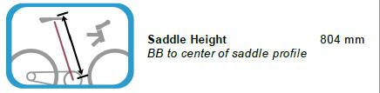

First we want to position the saddle both vertically and horizontally in space relative to the bottom bracket. The saddle height is measured from the centre of the bottom bracket to the top/centre of the saddle (imagine a straight line through the centre of saddle the rails). It’s important to remember that if you have your saddle a long way forward or a long way back, your tape measure will not be running in line with the seat tube.

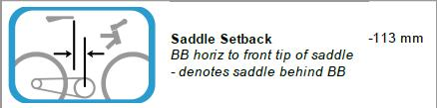

Next we need to adjust the saddle fore and aft. This measurement is the distance that the tip of the saddle is behind a vertical line through the bottom bracket. I’ve spent ages messing around with plum bobs and big T squares trying to do this and half the time coming up with a different measurement each time. The best technique I’ve found is this:

1. Put the bike in a level stand with the rear wheel against a wall,
2. Measure horizontally from the wall to:

A: The centre of the bottom bracket,

B: The tip of the saddle,

1. A-B= Saddle Setback

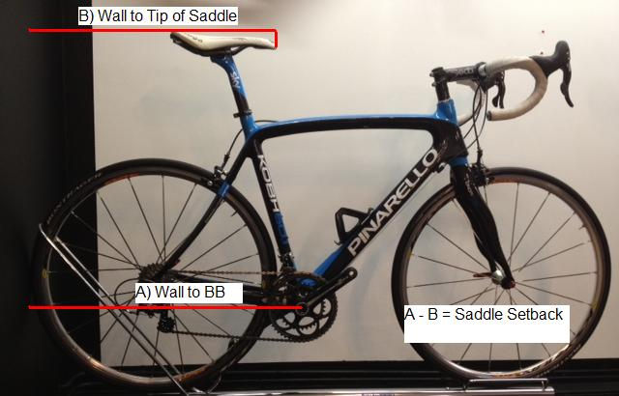

Obviously, if you move the saddle backwards, you take it further away from the bottom bracket and effectively raise the saddle height. Visa versa, if you lower the saddle height, the saddle moves horizontally closer to the bottom bracket due to the angle of the seat tube. Because of this, you’ll need to re measure the saddle height and setback after each adjustment until it’s in exactly the correct position.

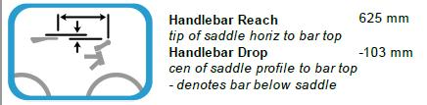

Ok, now we’ve positioned the saddle in space, we’re going to use it as a reference to position the bars. The bar reach is a relatively simple measurement from the tip of the saddle horizontally to the middle of the handle bars. This can be adjusted with different stem lengths but as stems jump 10mm at a time, the maximum this can be out by is +/-5mm.

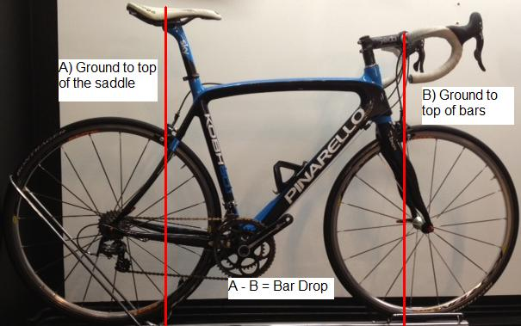

To measure the drop between the saddle and the bars;

1. Place the bike in a level stand.
2. Measure vertically from the floor to:

A: the top of the saddle

B: the top of the handle bars.

1. A-B = Drop between saddle and bars.

This can be adjusted by adding or removing spacers from under the stem or flipping the stem upside down.

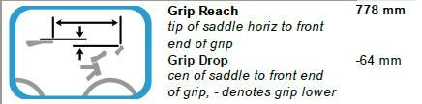

It’s more important to achieve the correct reach to the levers as opposed to the reach to the middle of the handle bar as that gives you the easiest access to the gears and levers. The reach the lever is made up of four parts: top tube length, stem length, horizontal bar reach, lever reach. There can be as much as a 3cm difference in length between different bar shapes. The lever reach is measured horizontally from the tip of the saddle to the tip of the levers.

The drop between the levers and the saddle is also stated on the PDF. This can be measured in the same way that you’d measure the handle bar drop but remember that the height of the levers is also dependant on what angle the levers are rotated.

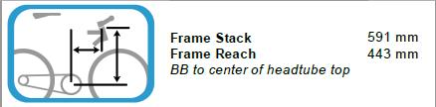

Stack and reach is a measurement system that more and more bike manufactures are using to describe the position of the top/middle of the head tube in relation to the bottom bracket. The stack refers to the vertical distance while the reach refers to the horizontal distance. If your fitting was done on your current bike, the PDF will show your current frames stack and reach. If your fit was done on the Retül Müve, the frame reach will be what the frame needs to be with the length stem that the rig was set up with. However, the vertical stack measurement is only representative of a bike with no spacers and a -6 stem because the Müve is not restricted on its vertical adjustment.

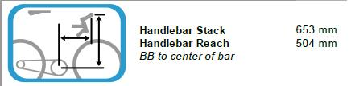

Therefore, when trying to work out what size frame is right for you, the best measurement to use is the bar stack and reach. This still uses the bottom bracket as the reference point but measures to the centre of the handle bars. This way you can work out the frame stack by deducting the spacer and top cap measurements along with the vertical component of the stem angle.

However, the easiest thing to do is leave it to the experts. The shop selling a bike should be able to figure out what size bike is needed to achieve the position. We are very fortunate that to work with some very good companies like Parlee that will produce a CAD drawing detailing exactly what stem and spacer combination is needed to achieve a desired position. As always, if you have any questions regarding your fit details, we’re only a phone call away.